1. Compiling_EddyPro_output.R

* Reads the most recent “fulloutput” file from EddyPro and appends it to all past data
* Makes a continuous timestamp column to prepare for gapfilling
* Creates L1 file

2. L2_filtering.R

* Filtering:
  + CO2 Variance maximum
  + Max/min value
  + RSSI bad flag
  + EddyPro qc flag

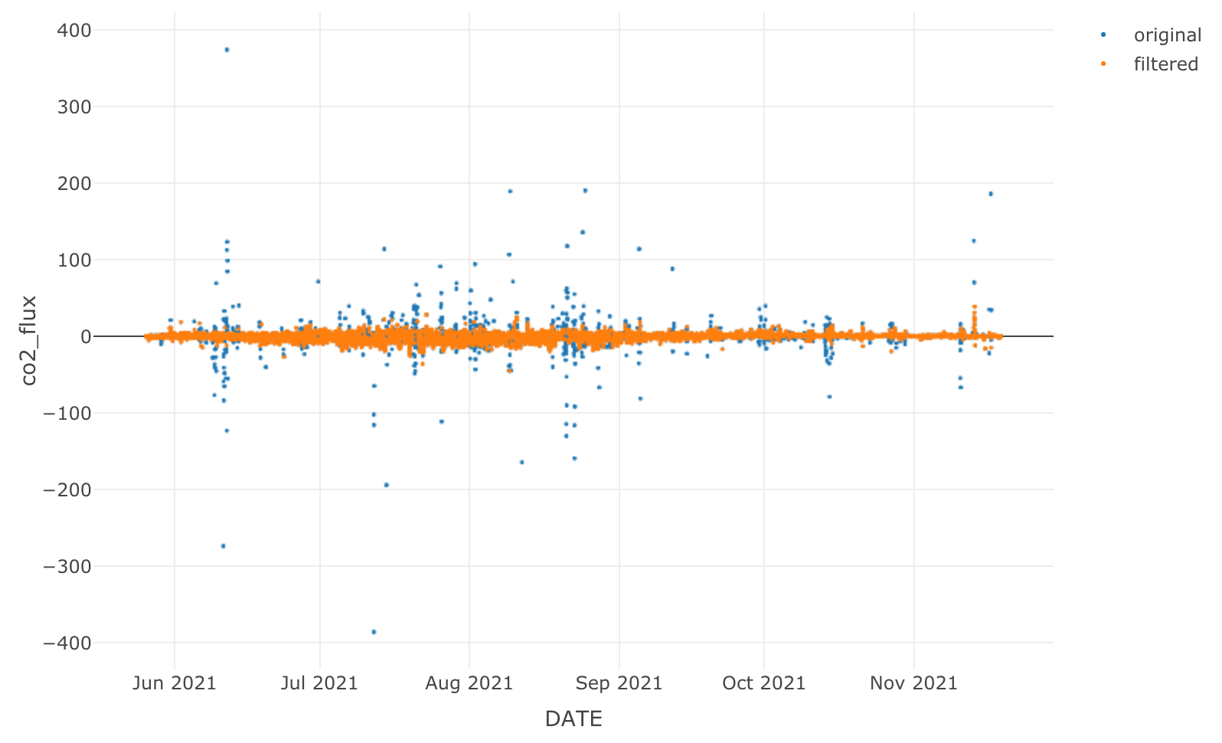

* Ustar filtering
  + Load “biomet” data from EddyPro to be used for filtering.
    - Preparation: fill data gaps with NA & continuous timestamp
  + Combine with L1
  + Estimate ustar threshold with EddyProc package.

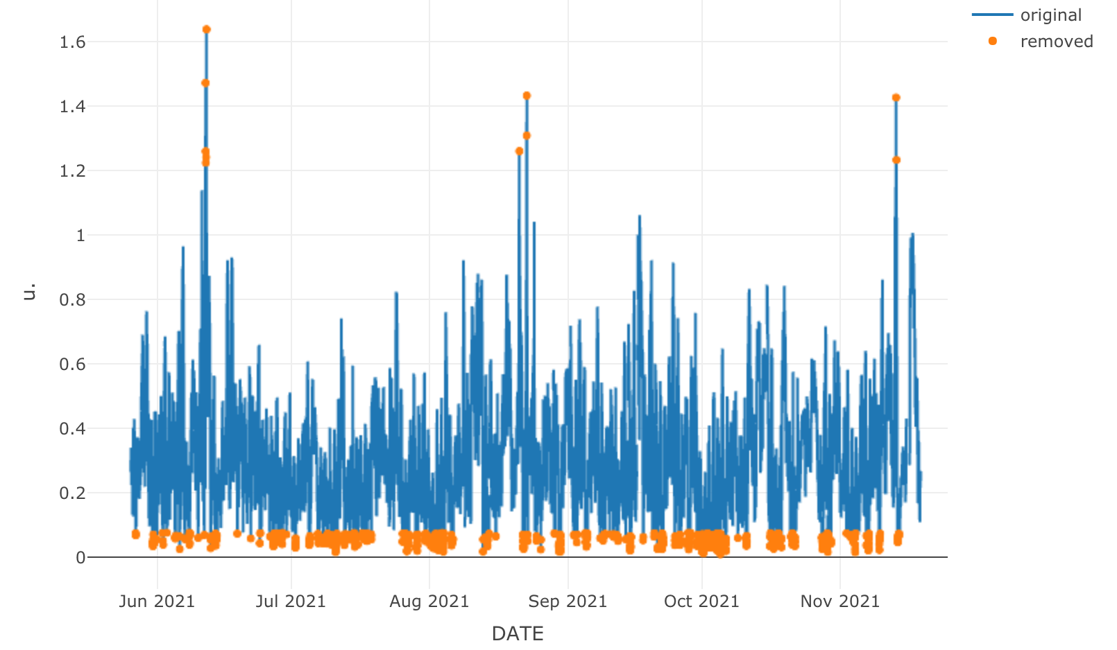

* + Apply ustar filter to every data point

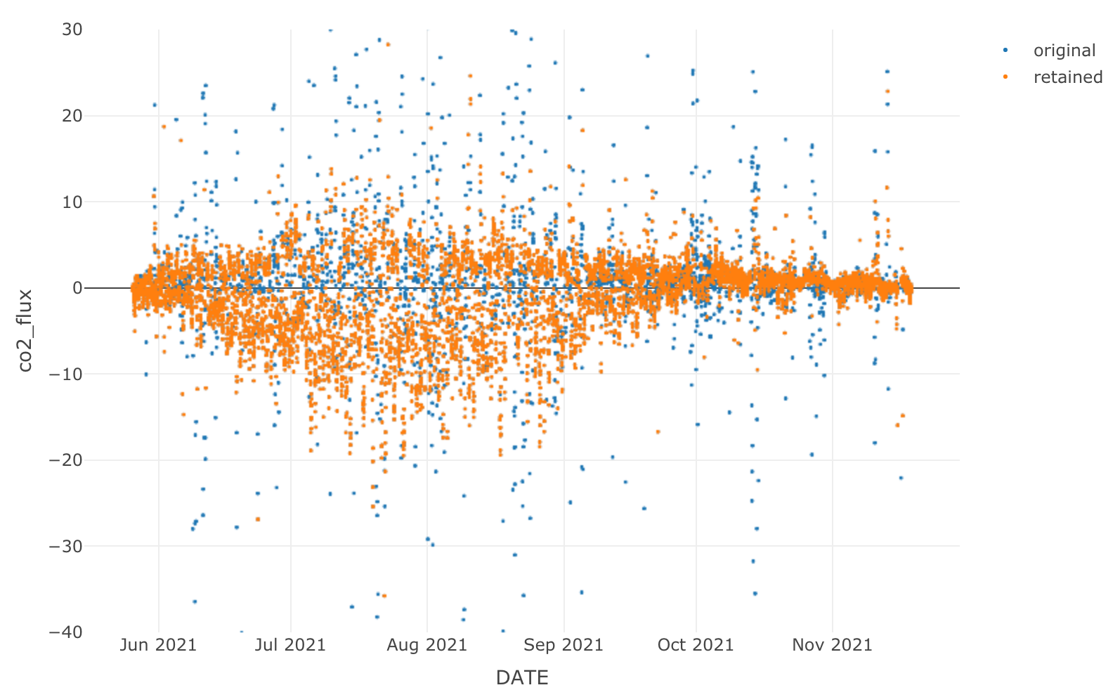

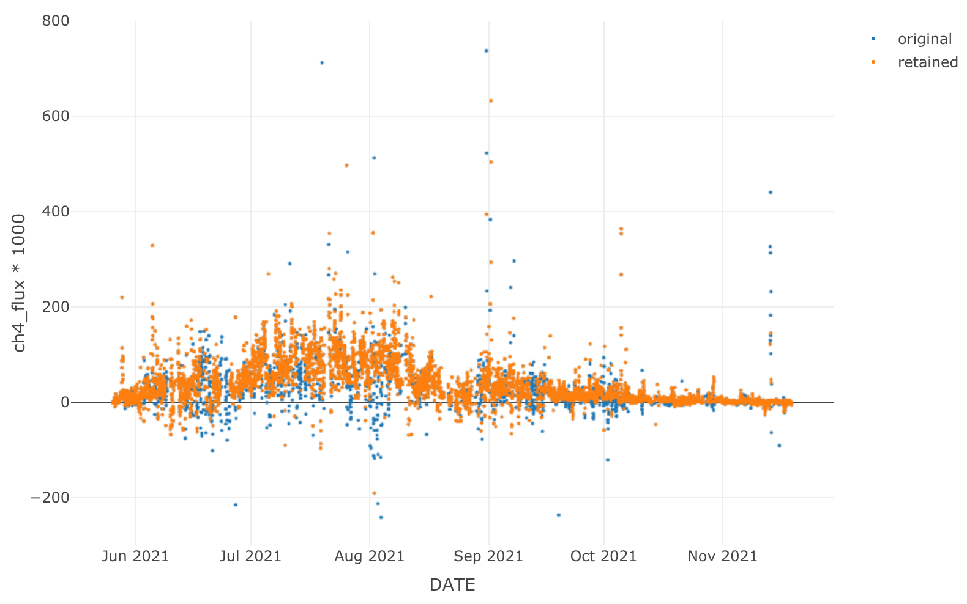

* + Creates L2 file.
  + Compiles met file used for partitioning

3. L3_Gap filling and RF

* Gapfill with MDSGapfill EddyProc package:
  + NEE
  + LE
  + H
  + Wind-dir
  + Tair
  + VPD
  + Rg
  + Tsoil
* Gap fill and partition with REddyProc_2:
  + GPP/RECO
* Gapfill CH4 with random forest 20x

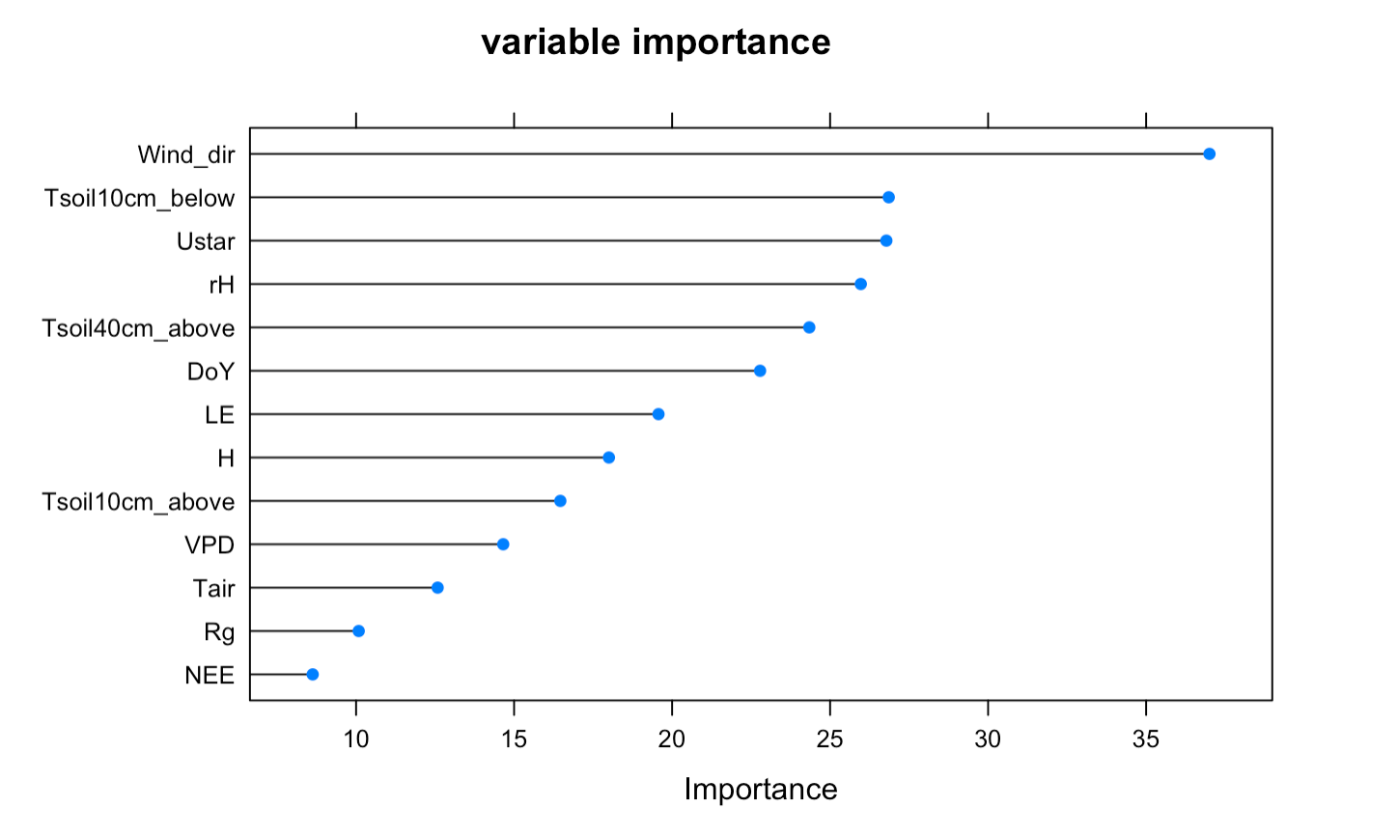

* Merge with L2
* Creates L3 file.